Dear Parents/Carers,
As you are aware reading is a vital part of your child’s education. Reading helps your child gain and develops a number of vital skills. Studies have shown that reading helps to develop vocabulary, develop understanding of knowledge and information, sharpen language and communicate skills and enhances concentration. Furthermore, we are fortunate to have joined ‘Oxford Owl’ an online reading scheme. Oxford Owl allows your children to access a wide range of books which can be listened to or read. After the children have read they can then go onto completing comprehension activities about the book.

Simply log on to the Oxford Owl website (www.oxfordowl.co.uk) using your class log in and access the e-book collection. Books can then be filtered and found according to your child’s reading ability.
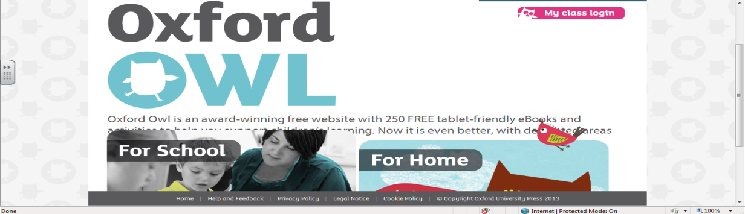

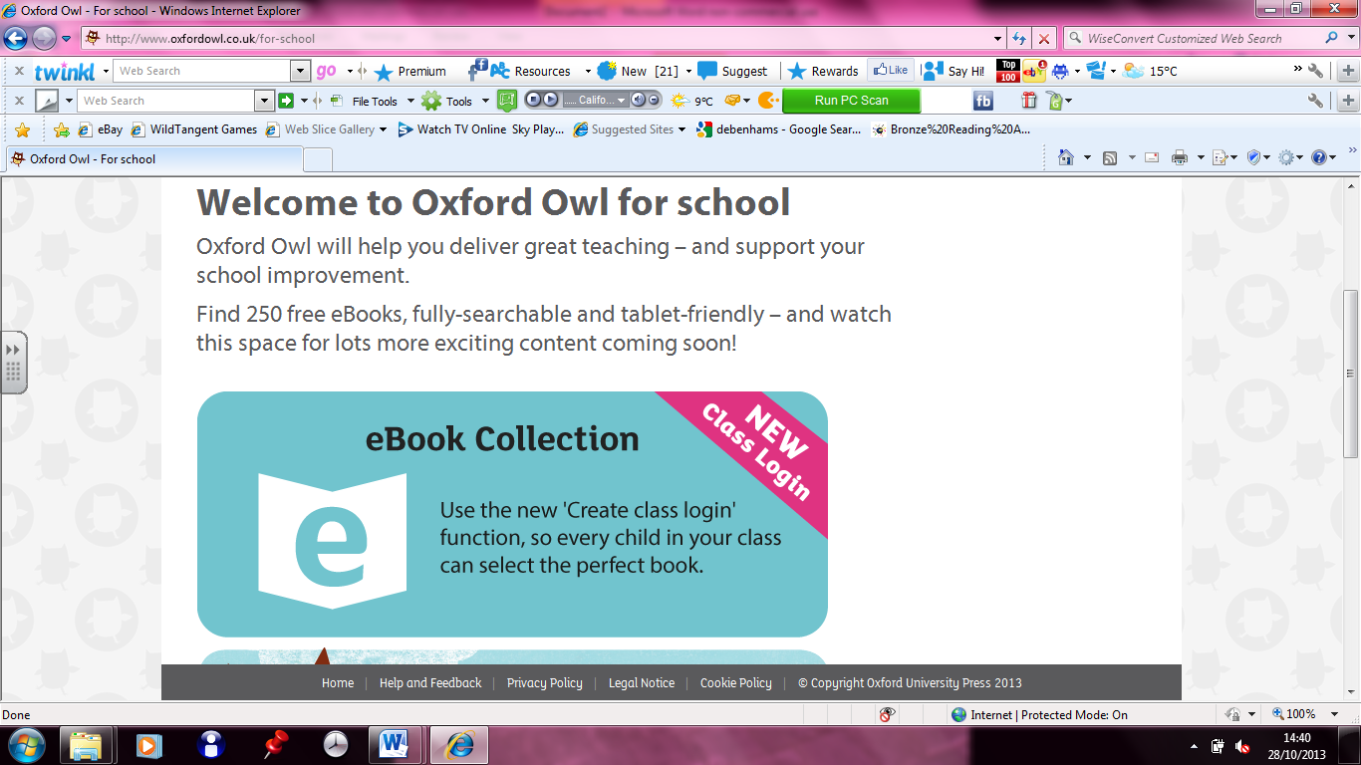

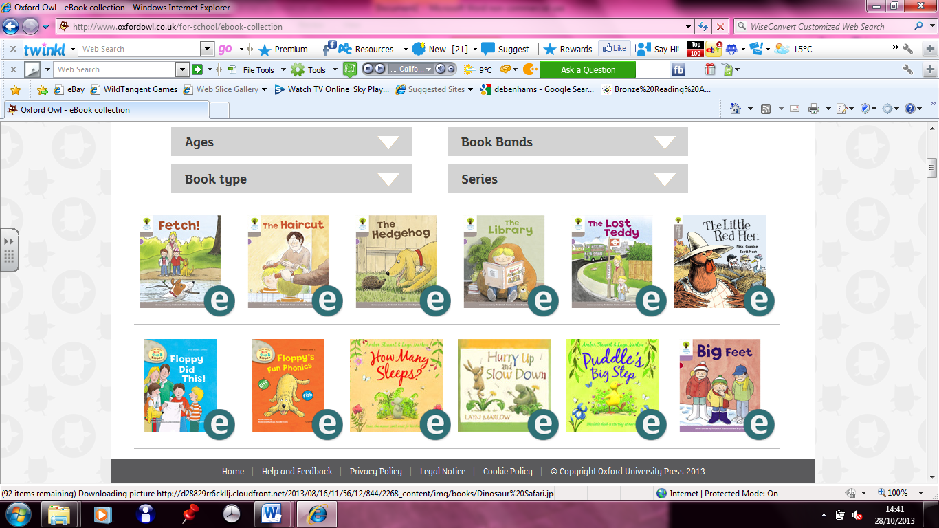

Oxford Owl also has a number of activities and videos to help support Phonics and Maths which can be found under the ‘at home’ section.
Please try your best to use this fantastic resource with your child. If you have any further questions please do not hesitate to come and see me.

Miss Anthoney

Log in details
Class Name | Username | Password
Nursery | sp n | nursery
RR | sp rr | rec1
RG | sp rg | rec2
1A | sp 1a | year1
1B | sp 1b | year1
2K | sp 2k | year2
2H | sp 2h | year2
3A | sp 3a | year3
3H | sp 3h | year3
4O | sp 4o | year4
4C | sp 4c | year4
5M | sp 5m | year5
5C | sp 5c | year5
6M | sp 6m | year6
6C | sp 6c | year6

