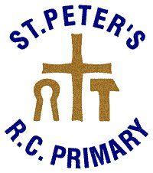
Responsible Internet Use Contract 2014
These rules will help us to be fair to others and keep everyone safe.
Everyone at St Peter’s is expected to follow these rules.
We use the school computers, Ipads and the internet for learning.

_ I will only use the Internet with my teacher’s permission.
_ I will not purposely delete other people's files.
_ I will not use any CD or USB flash drive at school without permission
from my teacher.
_ I will only e-mail or open emails from people I know, with my teacher’s
approval.
_ I will send polite and sensible messages.
_ When using the Internet or email, I will not give my home address or
phone number, or arrange to meet someone.
_ I will not chat to anyone online unless directed to do so by my teacher.
_ If I see anything I am unhappy with or I receive messages I do not like,
I will tell a teacher immediately.
_ I understand that the school may check my computer files and may
monitor the Internet sites I visit.
_ I understand that if I deliberately break these rules, I will be stopped
from using the Internet.

Child’s name:......................................... Class:............
Signed: Child:..........................................
Parent:........................................
Date:..........................................

