iPads Apps

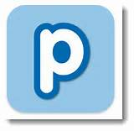
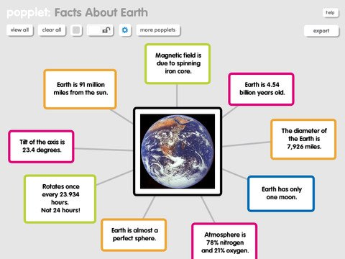
Popplet Lite
Brain storming app
Can be used to plan for writing and topic work.

.

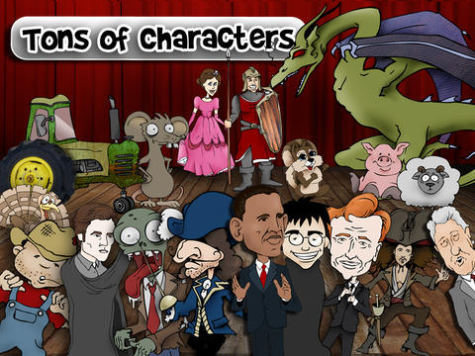
Puppet Pals
Create your own shows with animation and audio. Can select actors, backdrop and record the story (audio). Fairy tale package but can upload photos.

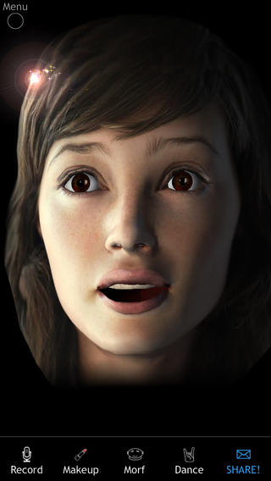

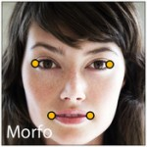
Morfo
Animate an image from camera roll or take new photo.
Can create the eye shapes, lip, nose etc.

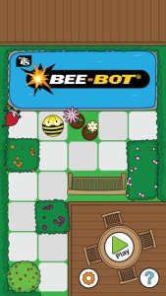
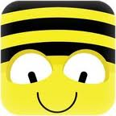
Beebot
Helps children to practise directional language.
Good for EYFS and KS1 control.
Same controls and format as the actual beebots.

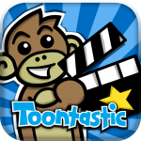
Toontastic
Toontastic is a creative way that children can draw and animate their own cartoons.

Tiny Piano
Touch the keys on the piano to play the song. 70 free songs (nursery rhymes, hymns etc.).

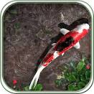
Pocket Pond HD (in the topic folder)
Create relaxing ripples while you enjoy the sounds of nature.

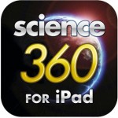
Science 360
Engaging science images and videos from around the globe
(KS2)

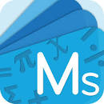
Mathletics
This app is the same as the Mathletics website.

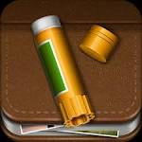
Story Creator
Create books using camera images, Images from online or by drawing images, add text or record you telling the story.

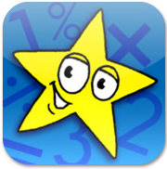
Doodle Maths

KS2 Interactive maths app
Multiple choice

