We, the family of St Peter’s, united in faith by God, strive to learn and grow together to be the best we possibly can everyday.

Newsletter Number 14 11th December 2015

Dear Parents and Friends,

Firstly a huge thank you to Miss Hughes who stepped in to cover for Mrs Sarwar who will return to 1S after Christmas. We are sad and delighted. Sad to see Miss Hughes go and delighted to welcome back Mrs Sarwar.

Junior Carol Service. Monday 14th 6pm all Y3-6 children should be at school in uniform, no jumpers from 5.40pm.

School Christmas Dinner – Wednesday 16th December
If your child normally has a packed lunch and would like Christmas dinner on 16th December, then as a one off, ParentPay are allowing a £2 payment online instead of the usual minimum payment of £10. Please make sure your child is in credit.

Y5/6 Athletics
Our team competed really well this week, we are getting better and better.

Christmas Jumper Day
St. Peter’s is supporting Text Santa on Wednesday 16th December.
Jazz up an old jumper or wear your Christmas jumper from last year.
Bring in £1 to support The Mac Millan Nurses, The Make a Wish Foundation and Save the Children.

Let’s Sparkle on the 16th!
Whoops-a-daisy Angel
Our Nursery and Reception children were brilliant this week in telling us the story of the Angel who was given an important job to do.

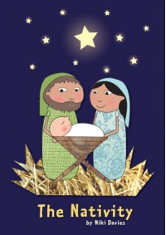
The Nativity
Y1 and 2 stepped up and were as brilliant as their younger peers.
A happy, lovely version of the Christmas Story told and sung amazingly.

Uniform
Girls should wear white socks. Earrings should be plain studs nothing else.
Coats should NOT be GREY. Black or dark blue only.

Happy Birthday 7th December – 13th December 2015
Brume Okuku 6, KC Nwankwo 9, Ohega Igiri 7.

Reception Admissions September 2016
If your child was born between 1st September 2011 and 31st August 2012 and you wish to apply for a Reception place in St Peter’s School then you
need to apply on-line at www.lbbd.gov.uk/admissions. All our Nursery children’s parents have been given a pack on how to apply and the documents required to complete the application. If you have a child born between the above dates and your child is not in our nursery and you wish to apply, pop into the office.

CLOSING DATE FOR APPLYING FOR A RECEPTION PLACE IS 15TH JANUARY 2016
Monday 14th December | 8.00am Yr 3/4 Athletics Club (by invitation only)  3.15pm – 4.30pm Yr 5/6 Athletics Club (by invitation only)  3.15pm – 4.30pm Yr 1 Boxing club (by invitation only)  6pm Junior Carol Service.
Tuesday 15th December  Y5M CSI | 3.15pm – 4.30pm Yr 5/6 Netball Club (by invitation only) 3.15pm – 4.30pm Yr 1/2 Football Club  Y1 London Zoo
Wednesday 16th December | 8.00am Pop Choir (by invitation only)  3.15pm – 4.30pm Yr 5/6 Fitness (by invitation only)  3.15pm – 4.30pm Yr 3/4 Football club  Christmas Jumper day £1 donation  Christmas dinner
Thursday 17th December | NO Yr 5/6 boys football  3.15pm – 4.30pm Change for life club (by invitation only)
Friday 18th December | 8am Yr 5 Judo (by invitation only)  8am Yr 5/6 girls football  9.30 Whole school assembly  School closes at 1.30PM

Yours sincerely, Mr D Craft Headteacher.

Christmas Festivities

14/12/2015 | 6.00pm | Infant Hall | Junior Christmas Concert  (Yr 3, Yr 4, Yr 5, Yr 6)
16/12/2015 |  |  | Christmas dinner  (£2 prepaid on ParentPay)
16/12/2015 |  |  | Christmas Jumper Day  (£1 donation)
18/12/2015 | 9.30am | Infant Hall | End of year assembly

SCHOOL CLOSES AT 1.30PM ON FRIDAY 18TH DECEMBER 2015

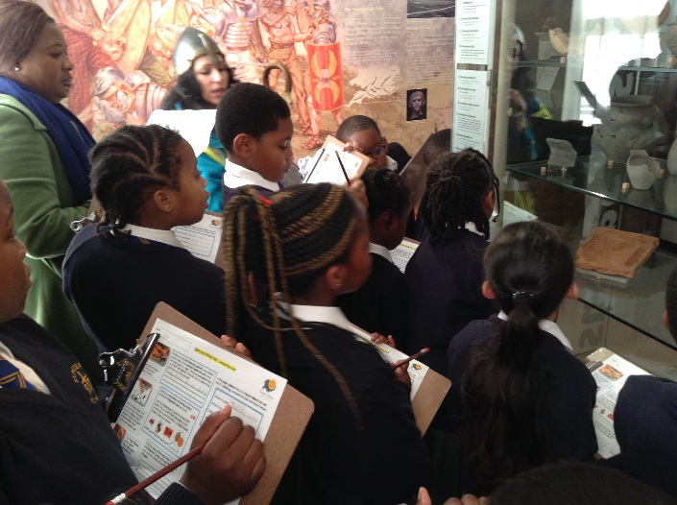
Year 4 at Vallence House

The children of Y4 had a most educational day studying Viking life this week.

Stubbers Outdoor adventure for Y5.
